**MNEMONICS DATABASE**

**PROJECT PROGRESS REPORT FOR**

**PRT 455**

**SOFTWARE ENGINEERING PRACTICE**

|  |  |  |
| --- | --- | --- |
| **NAME** | **ROLE** | **Contact details** |
| V Narendra | Subject faculty | nvellela@gmail.com |
| Rahul Rao | Project Team Member | rahulrao.v@gmail.com |
| Rahul Shokeen | Project Team Member | rahulshokeen94@gmail.com |
| Rakesh Tata | Project Team Member | rakcoolcracker@gmail.com |
| Aman Kathed | Project Team Member | amankanthed1994@gmail.com |

Contents

GitHub repository Details 3

Requirements 3

Functional requirements 3

Non-functional requirements 5

Security Requirements 5

User story Cards 5

UML Design 6

Class Diagram 6

Activity Diagram 7

Sequence diagram 8

Use Case Diagram 9

Search Mnemonic 9

Signup Use Case 10

Profile Use Case Diagram 11

Add Mnemonics Use Case Diagram 12

Login Use Case Diagram 13

Work done till now 14

Iterations 15

References 16

# GitHub repository Details

A repository was created to track developments and commits, the following link takes you to the repository- <https://github.com/rahulshokeen/PRT455>

# Requirements

## Functional requirements

The web application shall

* Take input as mnemonics from registered users.
* Display mnemonics i.e. Take search queries from all who wish to learn
* Allow registered users to rate the mnemonics on their like.
* Allow registered users to favorite a mnemonic they liked.
* Allow registered users to view their profile, which shows in a nutshell all the mnemonics added, favorites etc.
* When people enter a mnemonic, the web application should also prompt them to specify their organization and, if possible, enter the logo of their organization.  So, people might then enter mnemonics to promote their organization.
* The web application should provide users with the categories. They shall initially receive a drop-down menu with about 10 options: Psychology, IT, law, biology, chemistry, or other.  If they press “other”, they should be prompted to write a category.

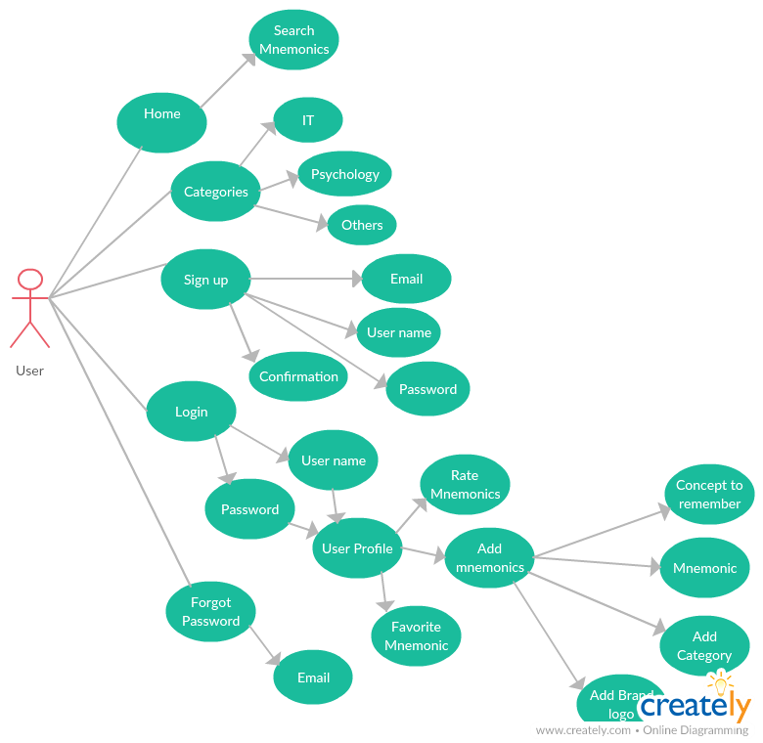

## Non-functional requirements

The web application should

* Be easy to use and the search process be accurate.
* Be available always.
* Not accept any entry of a mnemonic with a swear word in it.
* Be secure with the user details it holds.
* Be able to maintain the huge dataset and flow of mnemonics.
* Support all browsers and should function with ease on all platforms.
* Monitor the quality of mnemonics, it should have automated swear control mechanism.
* The web application’s response time for search queries should be less.

## Security Requirements

The web application shall

* Accept registration once a sign up is initiated.
* Verify the email id for verification of genuine users.
* Allow users which have successfully verified their email id to log in the portal.
* Allow registered users to change their passwords.
* Registered users to use the forgot password feature if they forget their password.

# User story Cards

As a **client**, I want a database for mnemonics as a web application so that it is readily allows people to search for relevant mnemonics. I also want that when people enter a mnemonic, I would hope they could also specify their organization and, if possible, enter the logo of their organization.  So, people might then enter mnemonics to promote their organization. Perhaps, with the categories f mnemonics, we could also prompt people, who enter a mnemonic to specify a category.  They might initially receive a drop-down menu with about 10 options: Psychology, IT, law, biology, chemistry, or other.  If they press “other”, they can then be prompted to write a category. Because they have already seen the previous options, they will hopefully choose a broad category. I would like no swear words in my database entered and there should be some mechanism to prevent that. I would like the users to register and once they register with their email id the email id should be verified for security purposes.

As a **user**, I need a web application which searches for the relevant mnemonics and makes my learning process easier. The web application should be providing me a personal space where I can list all my mnemonics and if necessary I can add some mnemonics for the community as well.

# UML Design

Class Diagram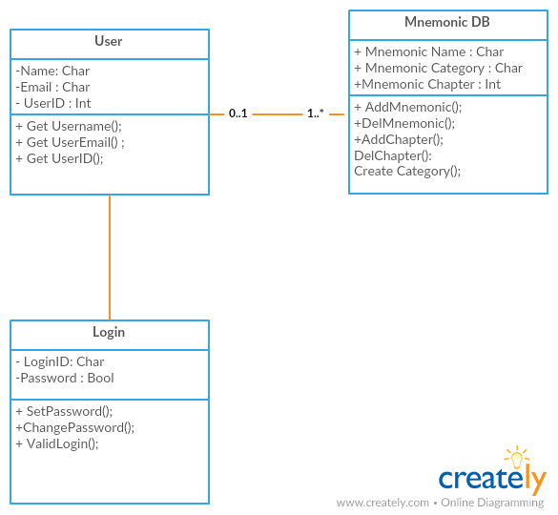

Figure-1 Class Diagra

## Activity Diagram

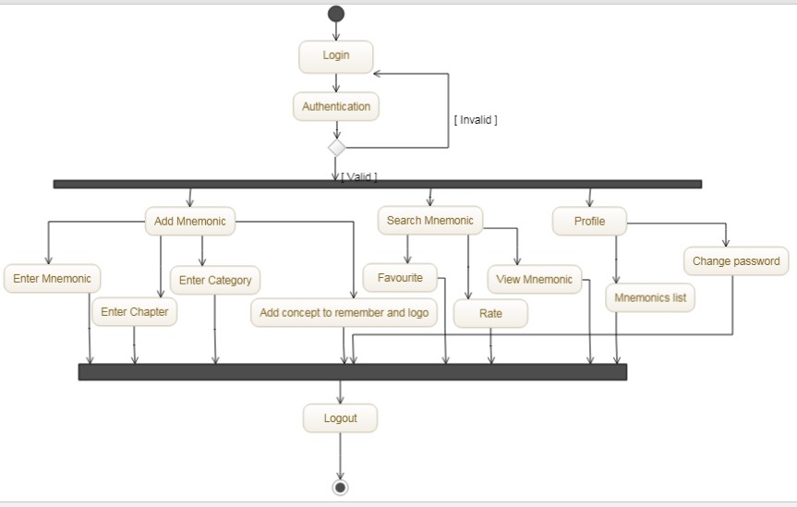

Figure-2 Activity Diagram

## Sequence diagram

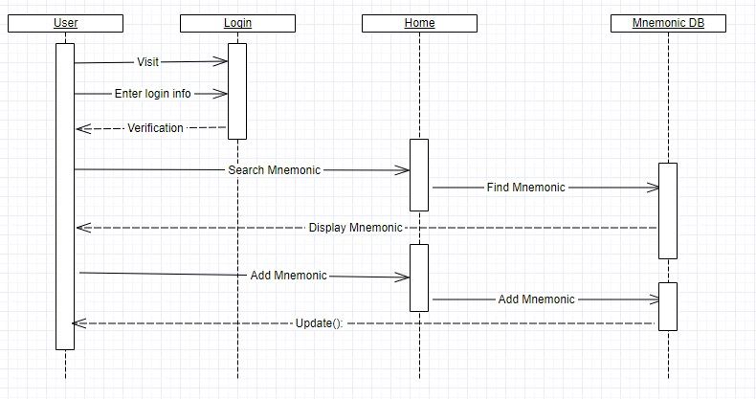

Figure-3 Sequence Diagram

## Use Case Diagram

### Search Mnemonic

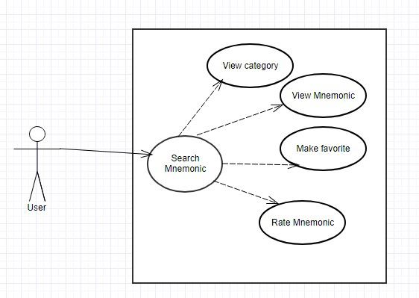

Figure-4 Use Case Diagram for Search Mnemonic

### Signup Use Case

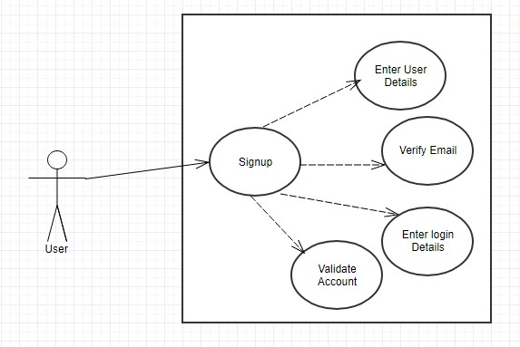

Figure-5 Sign up use case Diagram

### Profile Use Case Diagram

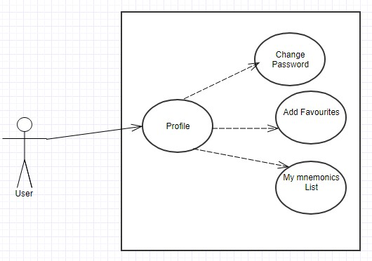

Figure-6 Profile Use Case Diagram

### Add Mnemonics Use Case Diagram

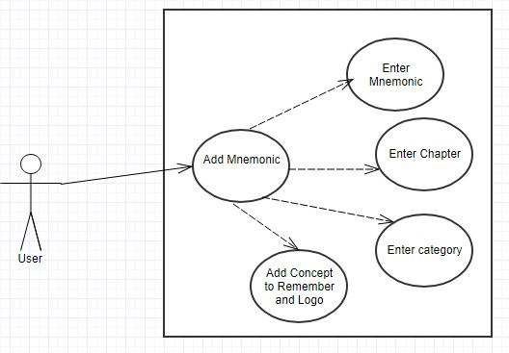

Figure-7 Add Mnemonics Use Case Diagram

### Login Use Case Diagram

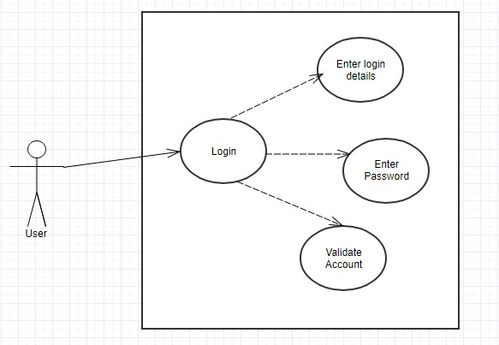

Figure-8 Login Use Case Diagram

# Work done till now

|  |  |  |
| --- | --- | --- |
| Work Done | Team member | Time frame |
| Project Introductory Submission | Combined Team Effort | First Three Weeks |
| Project Progress Submission   * Requirement’s * Activity & Class Diagram * State & Use Case Diagram | First Six Weeks |
| Project Development   * Database Queries Created * Added the database entity model to the website * Created a connection to the database * Registration Page * Login Page * Home Page * Adding Mnemonics into database through webpage | First Six Weeks w/ Mid Semester Brake. |

# Iterations

Our project could be more defined in 4 increments. The first increment was the basic prototype thing which showed the basic functionality of the mnemonics database. Mnemonic favorites, rating of mnemonics and average rating features are added. The second increment of the project witnessed email verification and functioning of the forgot password button. The third increment had a new design with more sharp buttons and an added swear control mechanism. The fourth and final increment of the project saw the categories coming up with a brand logo upload option at the time of new mnemonic addition.

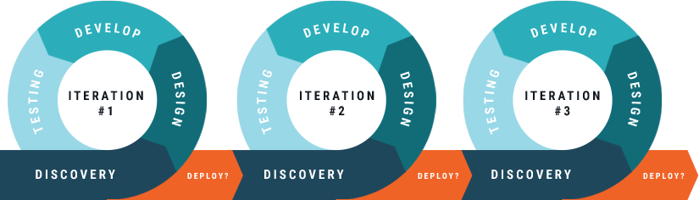

Deliverables at the end of 4 iterations:

Iteration 1: working prototype with working functionalities as rating of mnemonics, favorite a mnemonic, average rating of mnemonics etc.

Iteration 2: Email verification process and forgot password mechanism. Mnemonics added by feature added in this iteration.

Iteration 3: New design with sharper buttons and a working swear control mechanism came up.

Iteration 4: final increment with added categories option which categorizes the mnemonics and a brand logo upload option at the time of adding mnemonic.

# References

* COLLIER, K. W. 2011. Agile Analytics: A Value-Driven Approach to Business Intelligence and Data Warehousing. *CIO Insight***,** 30.
* Agile Alliance. (2017). *What is Agile Software Development?*. [online] Available at: https://www.agilealliance.org/agile101/ [Accessed 29 Sep. 2017].
* LARMAN, C. 2004. *Agile and iterative development : a manager&#039;s guide,* Boston ; London, Boston ; London : Addison-Wesley.
* Cockburn, A., 2002. *Agile software development* (Vol. 177). Boston: Addison-Wesley.
* Sommerville, I. 2011, *Software engineering,* 9th, International edn, Pearson, Boston.
* Brighthub Project Management. 2016. *What do You do with Change Requests in Software Project Development: the Handling Process*. [ONLINE] Available at: http://www.brighthubpm.com/change-management/5737-change-management-in-software-development-projects/.